Drive instruction manual

System requirements
- Windows XP/ Windows Vista /Windows 7 /Windows 8 /windows 10operating system
- Free USB port (1.1/2.0)
- 50 MB of disk space available

1. Installation
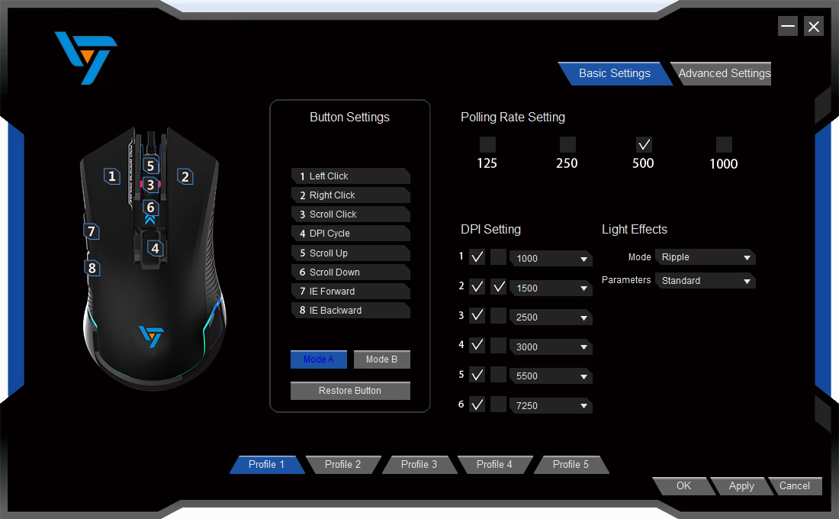
- Button setting：Define the button function of the mouse. The serial number corresponds to the key number of the logo on the left.

- Set interface switch：Including basic Settings and advanced Settings, advanced Settings are introduced on the next page

- Rate of return setting：125-250-500-1000 four gear set, click on the check

- DPI setting：Set the mouse's DPI (to be covered in detail)

- Lighting effects：Adjust the lighting effect of the mouse, select the corresponding mode and parameters in the drop-down box

- The configuration file：The five sets of configurations are equivalent to defining five sets of different "basic Settings"

- Apply：Click the apply button to write the current "basic Settings" to the mouse;Cancel: exit drive;Determination: application function + exit driver

Note：The change of the basic setting needs to be applied to the application, the application process is to re-write the parameters to the mouse, and the mouse appearance of carton is normal

⑴Introduction to key Settings
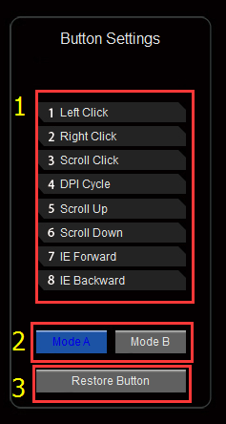 Figure 1 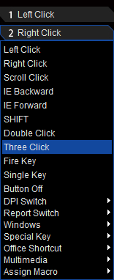 Figure 2 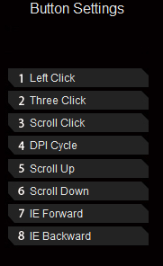Figure 3

To define the right for combo 3 as an example, click on the figure 1 'the right mouse button will pop up, figure 2 in figure 2 to choose three combo, as shown in figure 3, after the completion of the original "the right mouse button" has become "three combo" function and finally button click application is complete the key definition, the same is true of other key definitions.

Figure 1 shows the function of the current mouse button and the ability to support the custom button, and 3 indicates the shortcut button to restore the key to the default function

Figure. 2 introduction of key function:
①The mouse button, the right mouse button, the universal scroll key, the back direction button, the forward direction key, double - click, three clicks the normal function keys of the mouse
②Fire key: set up the keyboard single key function, support speed and frequency Settings, click the function to elaborate
③Single key setting: setting keyboard single key function, not support speed and frequency setting
④Key shut down: after setting, this key has no function
⑤Switch of resolution: switch with the mouse DPI function
⑥Return rate switching: same as the rate of return
⑦Windows, special buttons, word office, multimedia: quick key collection, including my computer, copy, volume control and other functions
⑧SHIFT: the mode switch function, the Settings are divided into mode, mode 2 (figure 1, 2), in a model will be a button below is set to 'SHIFT' application, after the long press and hold the button, other buttons will become mode under the two functions
⑨Macros: in the driver, it can be understood to be custom one and multiple keyboards or mouse button functions (in detail below)

Note: in order to ensure the normal use of the mouse, the driver will not be allowed to have the function of the left button in the setting of the key.Scrolling up and down can't always be pushed down, so it has fewer customizations than other buttons

⑵DPI set to introduce
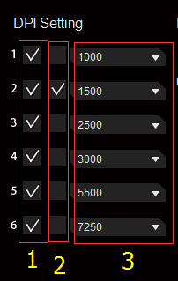
Figure 1 shows the number of segments currently set by the DPI, which can be selected from 1-6 paragraphs by clicking check
Figure 2 shows the current location of the DPI, which can select the current gear
Figure 3, the DPI values of all segments are represented, but the DPI can be chosen differently

⑶Introduction of lighting effect
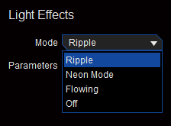
The mode includes ripple, neon mode, flowing, off, parameter support speed regulation

2. Advanced Settings page introduction
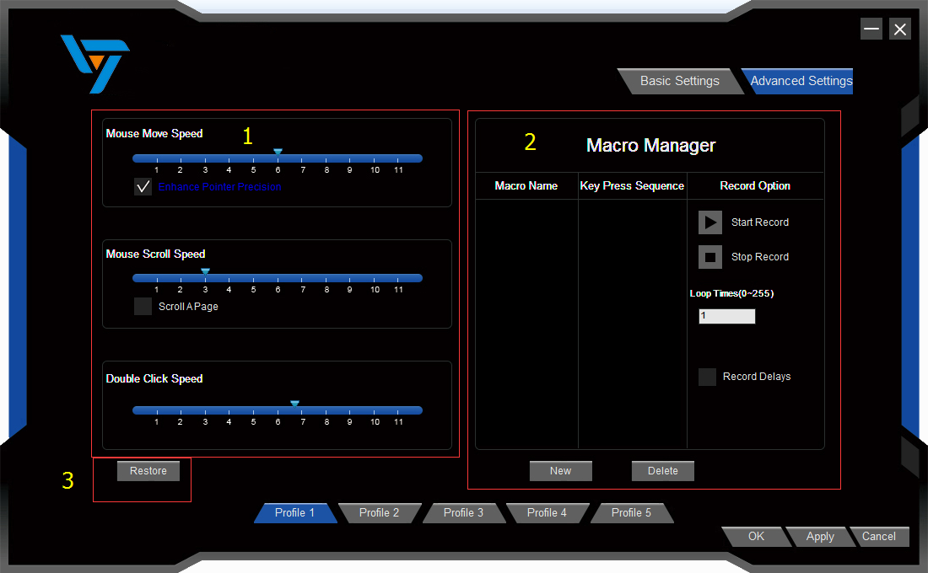
- Mouse property Settings：Control panel - mouse property Settings
- Macro manager：New, edit and delete macro
- Restore the default：Return mouse to default (including basic Settings and advanced Settings)

3.Macro introduction
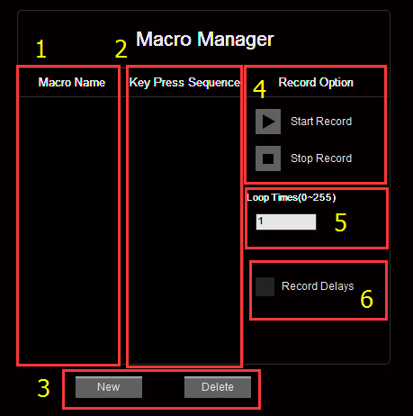 Figure 1 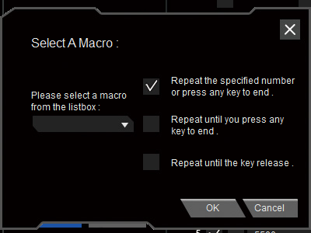 Figure 2
Macro name: name of all macros
- Key sequence: display the input content
- New and delete: new and delete macros
- Start recording, stop recording: start or stop recording macro content
- Number of cycles: the number of play macro content, corresponding to the number of the first item in figure 2
- Recording delay: record the time before the key is entered when the macro is entered

The steps are as follows:
1. Click "new", enter the macro name, and then click on the blank to save it
2. If you need to record the delay according to the actual choice, click "start recording" and click "stop recording" when the corresponding key function is completed.
3, If have changed, can be directly after the stop recording in key sequence right click modify (optional insert delay, insert the mouse button, modify lag, delete, delete button lag and supplementary recording)
4. After the entry is completed, select "macro" in the "key setting";Select a new macro command in figure 2, select a type of hair code, click "ok", and finally click "apply"

